Kilkenny County Council's Management Structure is:

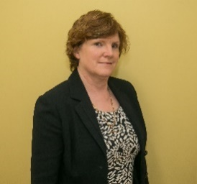 | Colette Byrne  Chief Executive  056-7794070  secretar@kilkennycoco.ie | Chief Executive of  Kilkenny County Council
 | Mary J. Mulholland  Director of Services  056-7794900  mary.mulholland@kilkennycoco.ie | Director of Services with responsibilities for:  Housing, Community, Library, Arts, Heritage, Fire Service  Municipal District of Callan/Thomastown
 | Tim Butler  Director of Services  056-7794070  tim.butler@kilkennycoco.ie | Director of Services with responsibilities for:  Corporate, Human Resources, Roads & Transportation, Water Services, Communication, Health & Safety  Municipal District of Kilkenny
 | Sean McKeown  Director of Services  056-7794010  sean.mckeown@kilkennycoco.ie | Director of Services with responsibilities for:  Planning, Environment, Building Control, Parks, LEO/Economic Development, Tourism Marketing & Veterinary Services  Municipal District of Piltown
 | Martin Prendiville  Head of Finance  056-7794214  martin.prendiville@kilkennycoco.ie | Director of Services for responsibilities for:  Finance, Information Technology, Facilities Management, Procurement & Special Projects  Municipal District of Castlecomer

